Project Update #1 – July 2012

Complementary Cropping Project Commences

In late 2011 a large scale project examining complementary break crops for sugarcane commenced. One of the project aims is to trial different rotational cropping systems and assess their impact on the profitability and productivity of the following cane crop. Associated with this is a time of planting trial and a break crop rotational trial.

The second aim is to conduct agronomic trials to provide better and more relevant management strategies that are specific to growing break crops such as mungbeans, maize and soybeans in the Burdekin region. This is to ensure break crops in the sugarcane system are managed effectively in order to maximise returns.

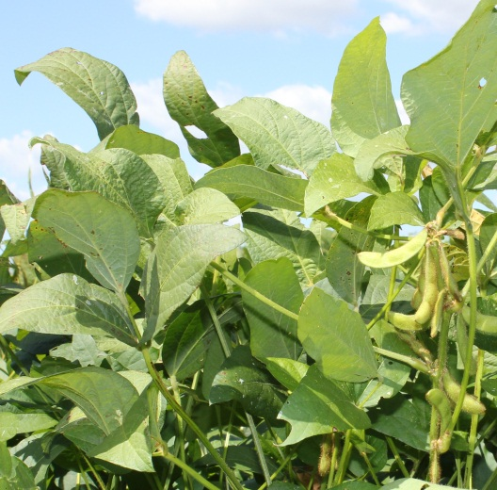
The project is a Joint Venture between the Grains and Sugar Research and Development Corporations (GRDC, SRDC), Queensland Department of Agriculture, Fisheries and Forestry (DAFF), BSES Limited and CSIRO. The Project is managed by DAFF.

Rotational cropping and time of planting trials

The rotational cropping and time of cane planting trials have commenced on a co-operator farm at Mona Park. The rotational cropping trial will comprise five different rotation schedules. These schedules consist of soybean, cotton, maize and mungbean in differing rotation sequences to compare short fallows to 18 month fallows. At the end of 2011 the first long rotation sequences were planted to Leichhardt soybeans and Roundup® tolerant cotton. Both of these crops have since been harvested and both replanted to maize. The short fallow sequences (mungbean and soybean) will be planted at the end of this year following the cane harvest, and all sequences will be planted back to cane in 2013.

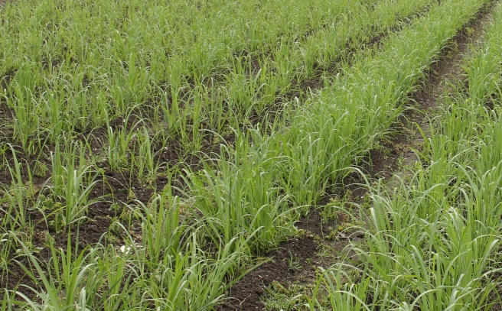
The time of cane planting trial has also commenced. Originally cane was going to be planted in March, May, August and October following either a bare or legume fallow (ebony cowpea). The legume fallow plots were all established in difficult conditions during December 2011. The first cane planting (planned for March) was not planted until late April due to wet conditions. Unfortunately the unseasonal wet weather has continued to affect the trial, with the May cane planting further delayed until August. This will still allow for the critical comparison of autumn and spring planted cane.
Upcoming Events

August 14 & 15

Certified Mungbean Agronomy Course
Ayr Research Station

This is a two day course conducted by Pulse Australia in association with DAFF, NSW DPI and the Australian Mungbean Association

Cost: $475 per person.
This includes all course materials and meals but not accommodation.

For registration forms or more information contact Gordon Cummings, Pulse Australia on 0408 923 474.

August 16

Soybean Agronomy Training Course
Ayr Research Station

This is a one day course conducted by Soy Australia in association with DAFF and NSW DPI.

Cost: $145 per person, ($125 for Soy Australia members).
Includes course materials and lunch

For registration forms or more information contact Gordon Cummings, Pulse Australia on 0408 923 474.

August / September
Date to be confirmed

Field walk at the Mona Park trial site

Agronomic trials

Agronomic trials for mungbeans are due to be planted in August at the Ayr Research Station. This first trial will investigate the interactions between time of planting, variety and plant density. Subsequent trials are planned to further investigate management and production options for the Burdekin, such as nutritional requirements, herbicide selection and row spacing.

Similar trials will also be conducted on soybean and maize. The information from these trials will be collated into a grain agronomy manual for the Burdekin and used to provide better advice to growers and consultants about growing grains in the Burdekin.

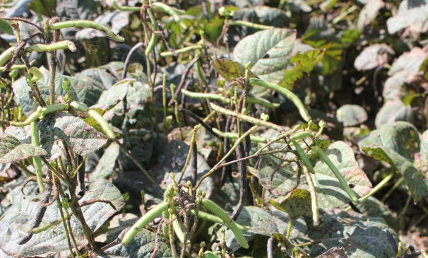

Call for Trial Co-operators

As part of the grains agronomy work co-operators are being sought for small plot nutrition trials for mungbeans and grain soybeans.

Potassium response trials will examine the impact of varying levels of K on plant uptake, grain quality and lodging. A zinc trial, comparing different rates of foliar applied zinc is also planned.

Trial sites on clay and sandy soils with high and low levels of potassium are required. If you can help, or would like more information, please contact Susie Bateman (DAFF) at the Ayr Research Station on 4720 5100.

